1. Create on bash script to check if a directory is available or not.

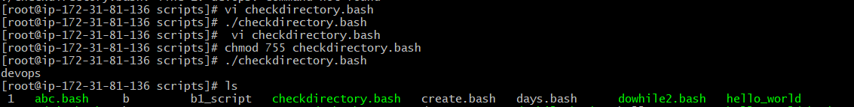

1. Create a bash script which will create multiple files.



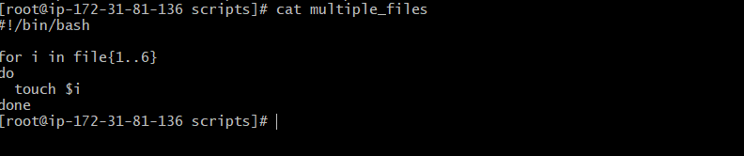

1. Create a bash script to take backup of a directory.

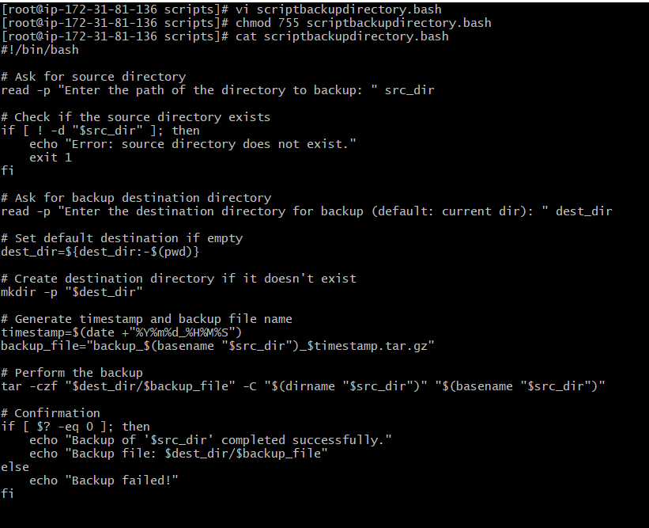

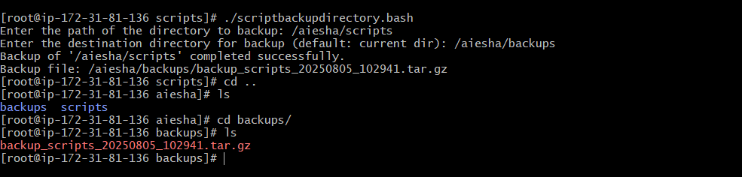

1. Create a bash script to install nginx in ec2 server.

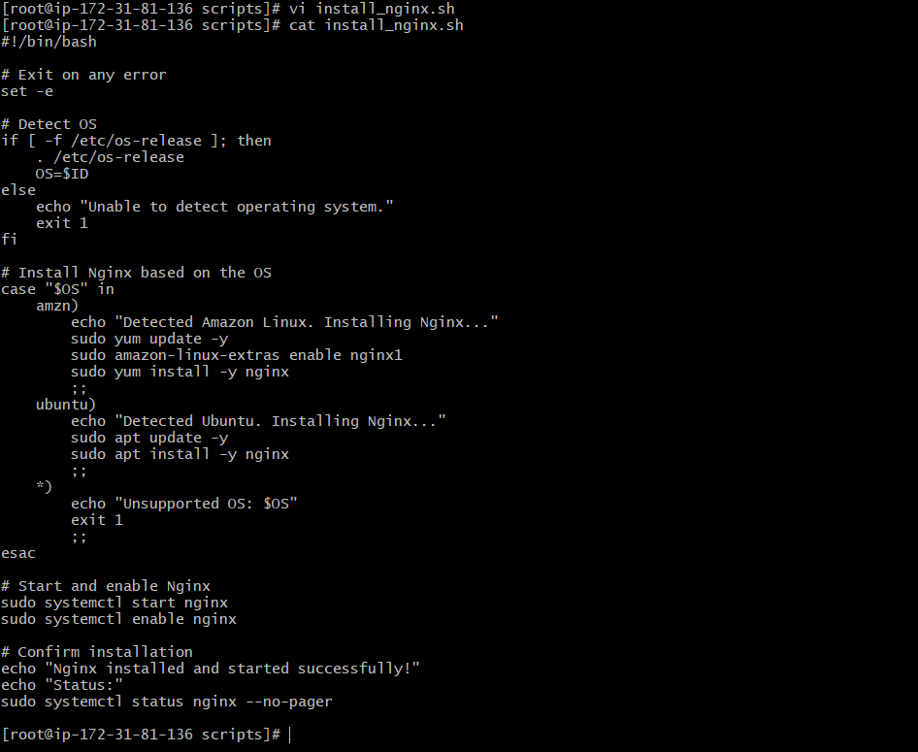

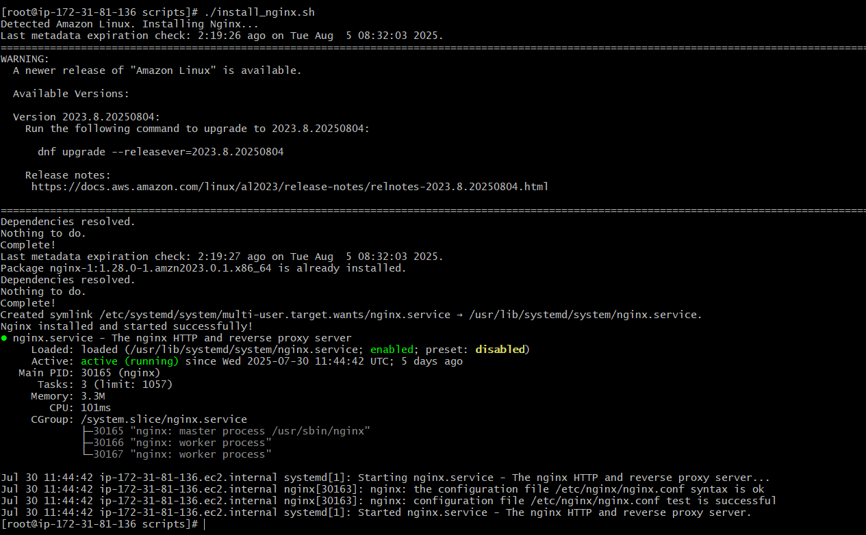

1. Create a bash script to install Apache Tomcat in ec2 server.

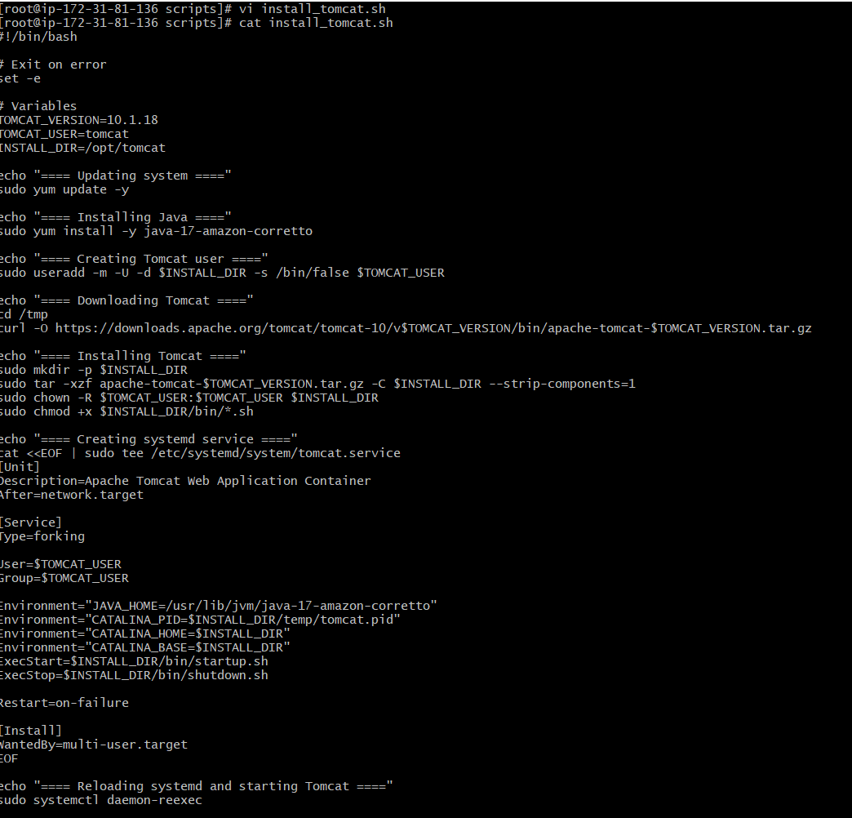

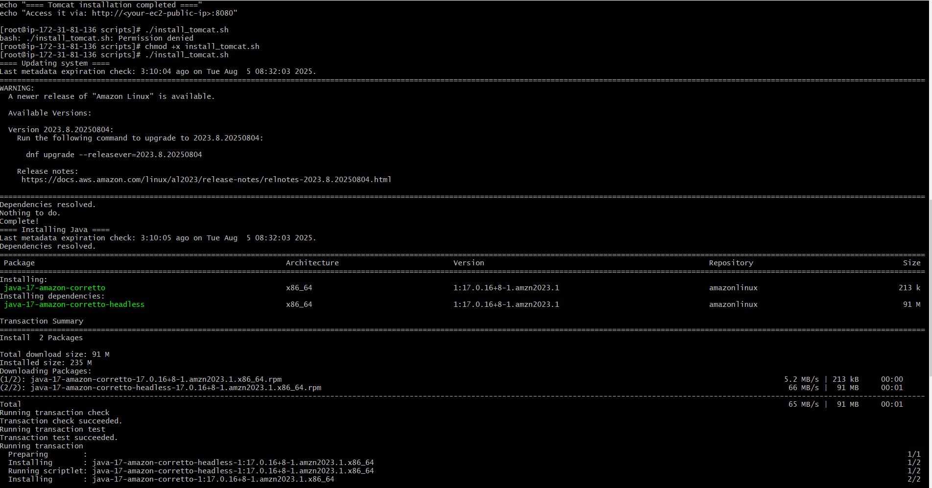

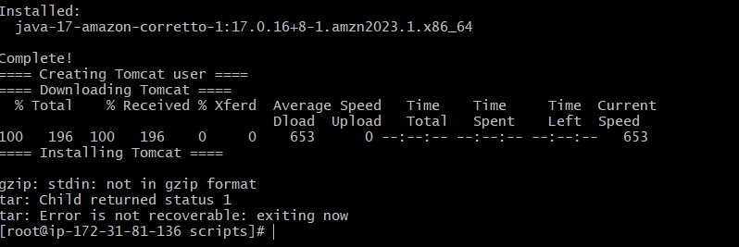

1. Create a bash script to check list if nginx service is running or not, if not running then script should start the service.

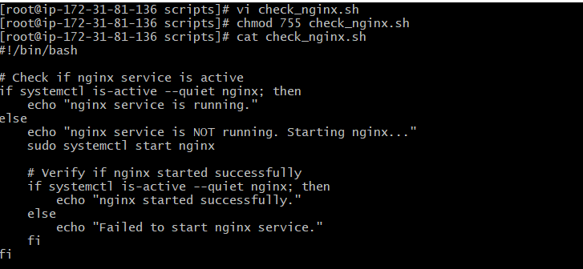

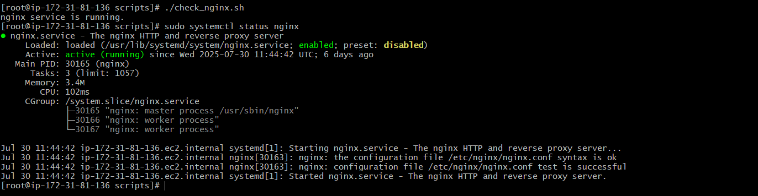

1. Create a bash script for calculator.

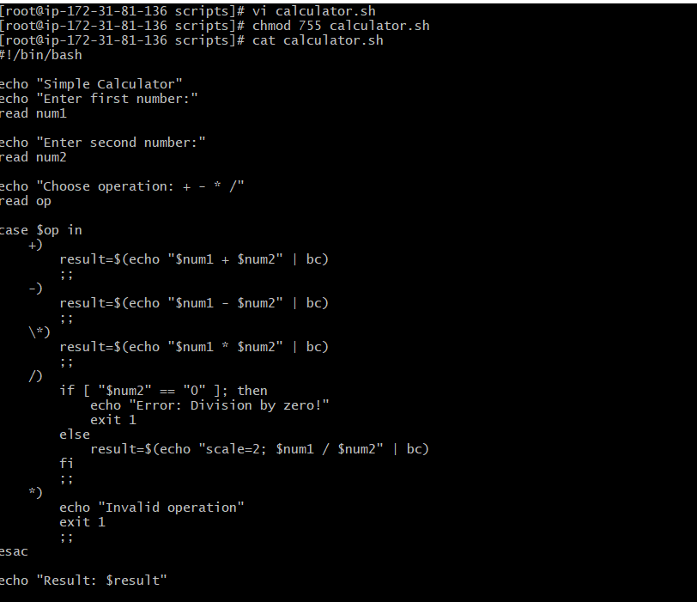

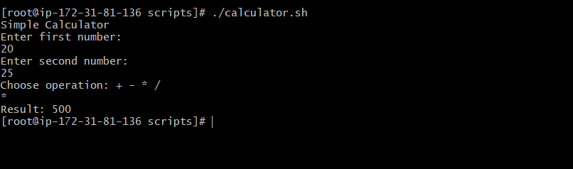

1. Create a bash script to check if directory is available or not, if not then create a directory.

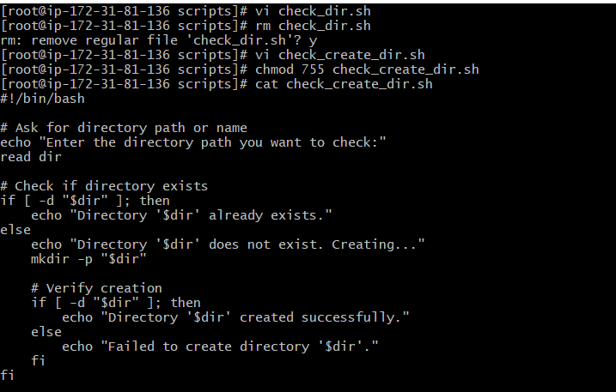



1. Create a bash script to delete last 3 lines for a file.

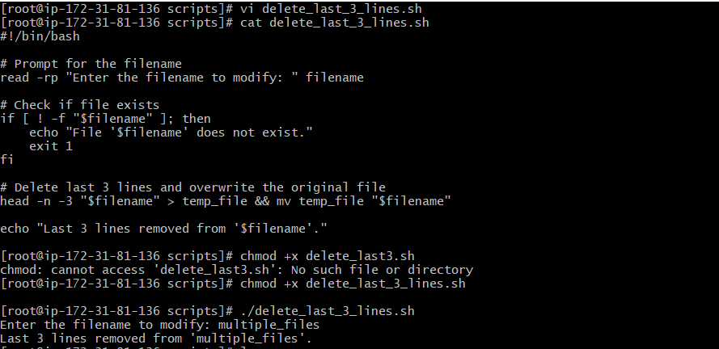

1. Bash script to monitor cpu and if it is more than 80% then send email notification.

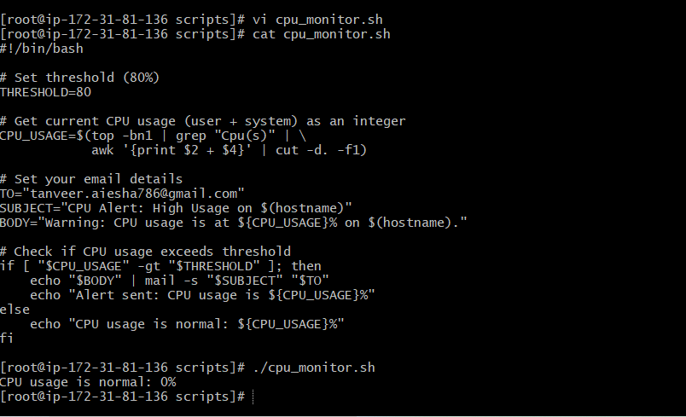

1. Bash script to monitor disk space and if it is more than 80% then send email notification.

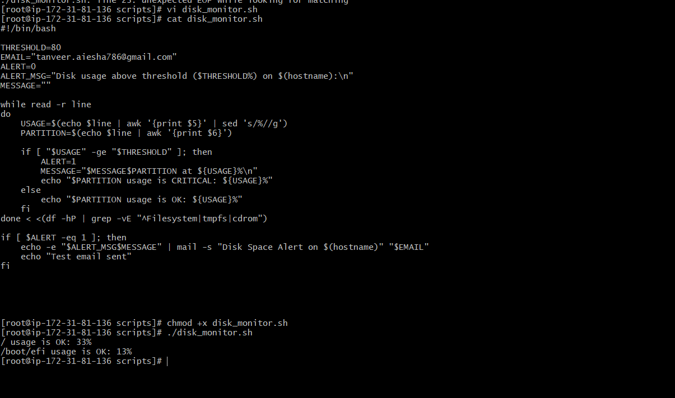

1. Bash script to monitor memory and if it is more than 80% then send email notification.

